# Pharmaceuticals

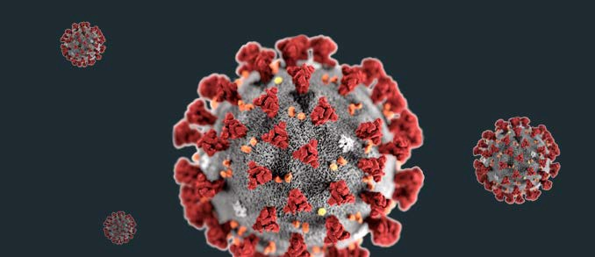

**Contaminants in the American water supply Cause the Spread for Covid-19**

## Introduction

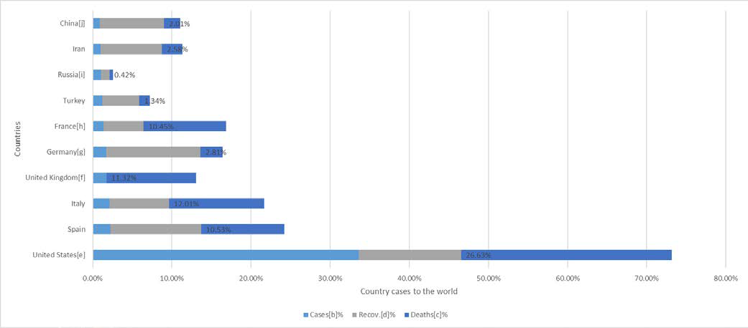

As the world hit with Coronavirus disease (COVID-19) and there is 3.19M cases Confirmed, 973K Recovered 228K Deaths Worldwide.

And as the United States is the most country effected with that disease 1,064,353 cases Confirmed, 126,325 Recovered and 61,504 Deaths.

Data calculation from google covid19 map from 30 April, 2020.

A few years ago I build an Excel sheet to predict when a product with an expiration date will get expire according to their consumption especially pharmaceutical product.

And as get Experian, I try to develop the idea for environment, so I make me research and found that Variety of free resource in USA Data from many articles and trusted web site .

So I try to but the idea in many.

My idea and project, I already submitted it before to Microsoft Azure AI Hackathon few-month age 10- July -10-September 2019.

[https://azureai.devpost.com](https://azureai.devpost.com/)

<https://devpost.com/software/product-in-markets-status>

In addition, I join **"IBM Digital - Nation Competition** “It is a local competition in Egypt. <https://www.linkedin.com/posts/sabineholl_ibm-developers-skills-activity-6594938995132719104-PJM8> [https://www.linkedin.com/posts/omarreda291_ibm-digitalnationafrica-competition-activity-](https://www.linkedin.com/posts/omarreda291_ibm-digitalnationafrica-competition-activity-6595038344034435072-c_5y) [6595038344034435072-c_5y](https://www.linkedin.com/posts/omarreda291_ibm-digitalnationafrica-competition-activity-6595038344034435072-c_5y)

[https://www.linkedin.com/posts/information-technology-institute-iti-_ibm-iti-mcit-activity-](https://www.linkedin.com/posts/information-technology-institute-iti-_ibm-iti-mcit-activity-6594175420088754176-XrFj) [6594175420088754176-XrFj](https://www.linkedin.com/posts/information-technology-institute-iti-_ibm-iti-mcit-activity-6594175420088754176-XrFj)

1. | P a g e

Also but the idea in Day One Project **“Federation of American Scientists”.**

<https://www.dayoneproject.org/day-one-accelerator>

And lately in AWS Develop a creative solution with ready-to-use ML models from **AWS Marketplace.**

<https://awsmarketplaceml.devpost.com/>

## Discussion

**The environmental side effects of medication:**

Let us first to found medication side effects in the environmental.

### Effect of drug disposal and environmental destruction.

**Drugs flushed into the environment could be cause of wildlife decline.**

[https://www.theguardian.com/environment/2014/oct/13/drugs-flushed-into-the-environment-could-be-](https://www.theguardian.com/environment/2014/oct/13/drugs-flushed-into-the-environment-could-be-cause-of-wildlife-decline) [cause-of-wildlife-decline](https://www.theguardian.com/environment/2014/oct/13/drugs-flushed-into-the-environment-could-be-cause-of-wildlife-decline)

### Contaminants in the American Water Supply.

Improperly discarded prescription medications are a growing threat to America’s water supply.

In South Carolina, **128 million prescriptions filled every year**, and about **40 percent** of them result in unneeded medicine thrown away.

**Antibiotic-resistant bacteria** already cause about [**65,000 deaths per year**](http://www.clarityway.com/blog/infographic-how-addiction-imports-environmental-damage/), and that number could rise if [proper medication disposal techniques](http://water.epa.gov/scitech/swguidance/ppcp/upload/ppcpflyer.pdf) are not followed well and safe.

<https://www.commdiginews.com/environment/the-cause-effect-drugs-environmental-destruction-32959/>

The drug residues detected in water supplies generally flushed into sewers and waterways through human excretion. Many of the pharmaceuticals known to slip through sewage and drinking water treatment plants.

That is up from **41 million people** reported by the **AP** in March as part of an investigation into the presence of pharmaceuticals in the **nation's waterways**.

[www.nbcnews.com/id/26662637/ns/health-health_care/Vmillion-us-have-drugs-drinking-water/#.XXvhkigzaUk](http://www.nbcnews.com/id/26662637/ns/health-health_care/Vmillion-us-have-drugs-drinking-water/#.XXvhkigzaUk)

In what described as the first large-scale study of the occurrence of hormones and pharmaceuticals in untreated groundwater aquifers, USGS researcher’s analyzed samples for **21 different hormones and 103 pharmaceuticals at 1,091 sites** around the United States.

<https://www.healthline.com/health-news/heres-the-drugs-that-can-show-up-in-drinking-water>

<https://link.springer.com/article/10.1007/s40572-014-0015-y>

<https://www.ncbi.nlm.nih.gov/pmc/articles/PMC1299201/>

### Report: U.S. drinking water widely contaminated with ‘forever chemicals’

The contamination of U.S. drinking water with **man-made "forever chemicals"** is far worse than previously estimated with some of the highest levels found in Miami, Philadelphia and New Orleans,

[https://www.cnbc.com/2020/01/22/us-drinking-water-widely-contaminated-with-forever-chemicals-](https://www.cnbc.com/2020/01/22/us-drinking-water-widely-contaminated-with-forever-chemicals-report.html) [report.html](https://www.cnbc.com/2020/01/22/us-drinking-water-widely-contaminated-with-forever-chemicals-report.html)

1. | P a g e

[https://www.stltoday.com/news/local/metro/report-u-s-drinking-water-widely-contaminated-with-forever-](https://www.stltoday.com/news/local/metro/report-u-s-drinking-water-widely-contaminated-with-forever-chemicals/article_45384354-50ee-5f20-8ef3-e3dc113c152a.html) [chemicals/article_45384354-50ee-5f20-8ef3-e3dc113c152a.html](https://www.stltoday.com/news/local/metro/report-u-s-drinking-water-widely-contaminated-with-forever-chemicals/article_45384354-50ee-5f20-8ef3-e3dc113c152a.html)

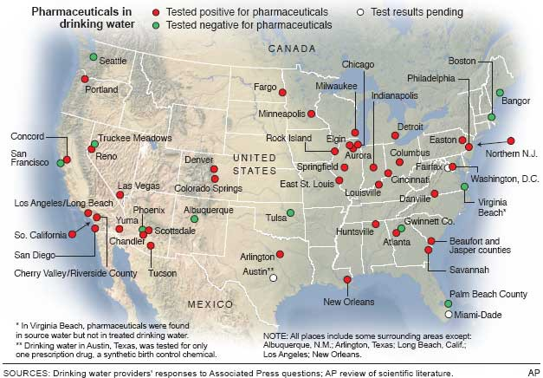

[https://www.usgs.gov/special-topic/water-science-school/science/pharmaceuticals-water?qt-](https://www.usgs.gov/special-topic/water-science-school/science/pharmaceuticals-water?qt-science_center_objects=0&qt-science_center_objects) [science_center_objects=0#qt-science_center_objects](https://www.usgs.gov/special-topic/water-science-school/science/pharmaceuticals-water?qt-science_center_objects=0&qt-science_center_objects)

## The Problem

I will Investigate Concentrations of Selected Pharmaceuticals and Antibiotics in USA water And as I see the problem is longer than a generation.

So we need to investigate the effect of Concentrations Pharmaceuticals and Antibiotics in USA water

in the long term.

[http://www.nbcnews.com/id/26662637/ns/health-health_care/t/million-us-have-drugs-drinking-](http://www.nbcnews.com/id/26662637/ns/health-health_care/t/million-us-have-drugs-drinking-water/#.XXvhkigzaUk) [water/#.XXvhkigzaUk](http://www.nbcnews.com/id/26662637/ns/health-health_care/t/million-us-have-drugs-drinking-water/#.XXvhkigzaUk)

<https://www.healthline.com/health-news/heres-the-drugs-that-can-show-up-in-drinking-water>

<https://www.ncbi.nlm.nih.gov/pmc/articles/PMC1299201/>

https://pubs.usgs.gov/ds/300/

## The method

#### Use data from trusted agency like USGS Water Resources to collect Pharmaceuticals and Antibiotics in USA water.

<https://waterdata.usgs.gov/nwis/qw>

#### Use data from hospital about drugs used to treatment USA people in COVID 19

Try to get a trend between them can cause Antibiotics resistance.

1. | P a g e

## Recommendations

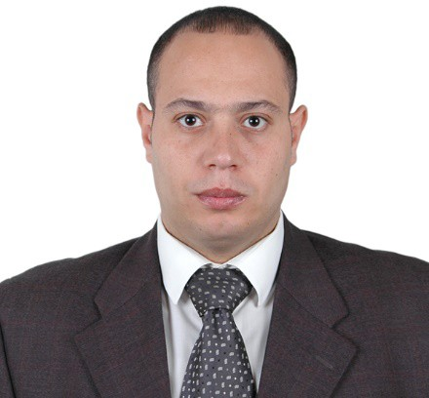

#### The research must include.

* Data analyst, data engineer.
* Pharmacies.
* Doctor.

To peter understand the result and read data.

**Conclusion**

I hope to the result will resolve our Question.

Are Pharmaceuticals and Antibiotics in USA water increase immunity acquired for drugs?

**Summary**

Do Pharmaceuticals Contaminants in the American water supply Cause the Spread for Covid- 19, affect weakened Human immunity for American and decrease the percentage of recovering and increase the death between people.

**Notice**

#### All free resource and link to articles are copyright to their author’s copyright and website.

* The method to get the relation between Pharmaceuticals and Antibiotics in USA water and drugs used to treat is free of copyrights.
* Project solution is to minimize the Expiration using Predictable formula and historical usage statistics And using machine learning are protected copyright.

**Abdelrazek RIZK.**

|  |
| --- |
| **Abdelrazek Rizk.** |
| Data Analyst Engineer |
| +20-1004904524 |
| +20-3-5342103 |

1. | P a g e